SECTION 1: INTRODUCTION AND BACKGROUND

Since the advent of the nuclear age, the fate of anthropogenic and naturally generated radioactive isotopes in the environment has been a major focus of groundwater transport studies. They can present a significant human and environmental health hazards. One isotope of concern is Radium, which was used as a phosphorescent compound historically, but sees little, if any industrial use today. The primary source of radium is then natural production by the decay of its parent products, uranium and thorium. While a natural radium signal exists in nearly all ground waters, it primarily presents a hazard in lower flux ground waters that are liberated from deep formations by anthropogenic processes such as hydrocarbon extraction or uranium mining. Hydraulic fracturing, in particular, has recently raised some concerns due to the elevated presence of radium in produced waters, with concentrations in excess of 120 Bq/L (Barbot, Vidic, Gregory, & Vidic, 2013). Improper storage or handling of the wastes could result in radium contamination of groundwater, posing a radiological risk to local populations. An understanding of how radium would migrate under these scenarios is important during planning for hydraulic fracturing operations.

In parallel, the radium isotopes also have been leveraged as naturally occurring environmental tracers. The primary example uses a mass balance of radium isotopes in estuarine and near shore systems to provide estimates of subterranean groundwater discharge (SGD). The method constructs a simple conservative mixing model of local groundwater containing naturally occurring radium isotopes to reach a desired off shore end member (Moore, 2003). While many of the predictions of this model have matched well with other methods, it is not able to resolve groundwater behavior within the estuarine systems. Unfortunately, the assumption of conservative behavior that is assumed in the near shore system is questionable in estuarine aquifers, especially given that radium isotopes are retarded by the presence of iron and manganese oxides (Gonneea, Morris, Dulaiova, & Charette, 2008). These systems experience rapid changes in solution salinity, pH, and redox state, making radium transport through them more complicated. Indeed, variations of radium release from estuarine groundwater has already been observed (Hughes, Wilson, & Moore, 2015). Aside from a natural groundwater tracer, radium has also been identified as a possible marker for historic spills associated with hydrocarbon extraction (Lauer & Vengosh, 2016). This is possible because the radium isotopic signature of many shales differs significantly from that of local shallow groundwater (Warner, Christie, Jackson, & Vengosh, 2013). Making full use radium as a tracer in both of these scenarios demands careful accounting of the critical processes controlling transport.

Radium isotope transport is dominated by advection and diffusion, where specific mineral phases control the aqueous radium concentration through sorption. Radium weakly forms complexes with carbonate and sulfate ions at pH values greater than 9, but is free radium for most environmental conditions (Grivé, Duro, Colàs, & Giffaut, 2015). Previous work has studied sorption by measuring and comparing distribution coefficients, Kd, finding that iron and manganese oxides dominate radium retention (Bassot, Stammose, & Benitah, 2005; Beneš, Strejc, Lukavec, & Borovec, 1984). While a useful indicator for the extent of radium retention in a given system, these coefficients are primarily empirical and are not easily adapted to dynamic systems or systems with differing mineral composition. As an example, a compilation of radium isotope Kd values saw significant variations in Kd for similar systems, even when only a synthetic iron oxide was considered (Beck & Cochran, 2013). More recent work has modeled data from radium sorption to ferrihydrite and goethite using a tetradentate binding site surface complexation model with good success (Sajih et al., 2014). While sorption of other group II ions to montmorillonites and other clay minerals is well studied (Bas, 2006), there is only a limited data set for radium sorption (Tamamura et al., 2013). Lastly, there is very little data examining the sorption of radium to reduced minerals that form during natural cycling of certain groundwaters. Understanding the full suite of minerals controlling radium transport will be key in predicting its behavior.

The objective of this work is to develop further understanding of radium sorption behavior and develop simple models of radium sorption that can be used in a wide range of groundwater studies. Previous work has almost entirely focused on the importance of iron oxides, but have not considered the role of clay minerals with exchangeable cations, or the importance of reduced iron minerals, both of which are commonly found in many aquifers. In this study, we first compare sorption of radium to ferrihydrite, goethite, sodium montmorillonite, and pyrite with a low salinity background solution, and then model that sorption through simple surface complexation models. The results show that pH plays a crucial role in determining sorption extent, and that while iron oxides do show extensive sorption, the most dominant mineral is in fact sodium montmorillonite. This result is mirrored in the surface complexation models, showing that exchange reactions result in the enhanced sorption of radium in the montmorillonite, as compared to the other minerals.

SECTION 2: EXPERIMENTAL AND MODELING METHODS

Reagents used in the experiments were of reagent grade or better, and all solutions were made with 18 M\Ohm water. Radium-226 stock was provided by the MIT Environmental, Health, and Safety office, and acidified to 3% using HCl.

2.1 MINERAL PREPARATION

Both ferrihydrite and goethite minerals were prepared using standard methods (Schwertmann & Cornell, 2000). Briefly, ferrihydrite was precipitated by dissolving Fe(III)Cl3 in water, and rapidly titrating the solution to pH 7-8, followed by centrifugation and washing to remove background electrolytes. The iron content of prepared ferrhydrite slurry was characterized using the ferrozine method (Stookey, 1970), and aliquots of the slurry were added directly to the experiments. Goethite was prepared by slow oxidation of an initially O2 free solution of Fe(II)Cl2 and bicarbonate using air over the course of 2 days. The resulting mineral was centrifuged and washed to remove background electrolyte, and then dried for 2 hours at 70 C. Both iron minerals were characterized using x-ray diffraction to confirm their composition.

Calcium montmorillonite STX-1b was ordered from the clay minerals society (clays.org). The clay was dispersed with 1 M NaCl, and the <0.2 um clay fraction siphoned off after successive washes with DI water. The siphoned clay particles were then treated with a 1 M Sodium Acetate solution, set to pH 5 using glacial acetic acid, which removed the carbonates. Since the mineral data from the clay society indicated low or negligible iron content, no iron oxide removal was performed. The cleaned clay was then washed and centrifuged with the experimental background solution, resulting in a sodium montmorillonite. The clay was dried at 50 C overnight, and then carefully ground using mortar and pestle.

Lastly, pyrite was ordered from Ward’s Science (www.wardsci.com), which came in a large ore form. The pyrite was ground using mortar and pestle, and then the 45-250 um size fraction were sieved out. The pyrite was placed into an anaerobic glove bag, with a 5% hydrogen and 95% hydrogen atmosphere. Once in the glove bag, the pyrite was washed in 6 N HCl overnight to remove any iron oxide coatings, and then washed with DI water. Lastly, the pyrite was allowed to air dry in the anaerobic glove bag with a dessicant. The pyrite composition was confirmed through XRD.

2.2 SORPTION EXPERIMENTAL SETUP

200 mL serum vials were filled with 100 mL of 10 mM NaCl stock solution, 30 mg of one mineral (except for the case of pyrite, where 40 mg was used), and 5-270 Bq of Radium-226 Stock. Experiments using pyrite were performed in an anaerobic glove bag with oxygen free solutions, while all others were performed in lab air. The pH was titrated to 3,5,7 or 9 +/- 0.05, and then the bottle was sealed with a butyl stopper. Bottles were shaken for 24 hours, and then the pH was checked and re-titrated to the desired value. Previous work has established that this is sufficient time for sorption equilibrium to iron surfaces (Sajih et al., 2014), while sorption to montmorillonite was evaluated using the same set up with different time points, as well as a desorption experiment described in the supporting information. If the pH deviated more than 0.1 pH units, then the bottle was allowed to equilibrate for 15 minutes, and the re-titration process repeated. HCl and NaOH at high concentrations were used for all titrations, so that volume additions did not exceed 5% of the original volume. Once re-titration was complete, the samples were filtered using 0.22 um polyethersulfone filters, which was shown not to significantly sorb radium. Experimental error was quantified by measuring the standard deviation of triplicates for each data point.

2.3 ANALYTICAL TECHNIQUES

Solutions of radium were quantified using scintillation counting techniques. 10 mL of sample (5 mL of Sodium montmorillonite supernatant due to filtration difficulty) were mixed with 10 mL of Ultima Gold XR (Perkin Elmer) and sealed for 30 days to allow radium-226 to reach a transient equilibrium with its daughter products. The equilibrated samples were then counted using a Beckman Coulter LS 6500 scintillation counter, and the resulting counts were compared to a calibration curve of similarly prepared radium-226 standards to determine solution activities. Except for points involving ferrihydrite at pH 9, this was sufficient to determine the extent of sorption and develop isotherms. Background concentrations were also quantified to develop a limit of blank of 1.4 counts per second (cps). We only considered any samples having 1.5 times that limit in subsequent analyses.

Many supernatant samples using ferrihydrite at pH 9 were below this defined detection limit, so solid associated radium on the filtered ferrihydrite itself was counted using gamma spectroscopy in addition to the scintillation counted supernatant. A Canberra low energy germanium detector with a Canberra multichannel analyzer was calibrated using a multinuclide standard from Eckert and Ziegler (www.ezag.com). Counts were determined using the Canberra Genie software, which performed peak identification, peak area summation, background subtraction, and nuclide activity calculation. Radium-226 was primarily counted through the 186 keV peak. The solid samples on PES filters were simply placed in scintillation vials, and counted directly on the counter, with the resulting counts being adjusted for ferrihydrite loss during filtration. The physical arrangement arrangement closely matches that of the multinuclide standard, so no geometry corrections were used.

[DISCUSSION OF SURFACE AREA ANALYSIS]

2.4 SURFACE COMPLEXATION MODELING

Radium binding to mineral surfaces was modeled through a double diffuse layer (DDL) surface complexation model implemented in PHREEQC (Parkhurst & Appela, 2013). Simple single site models were used to fit the data, which allows for easy comparison of the relative importance of the different minerals for radium retention, as well as comparison with currently existing surface complexation modeling results (Dzombak & Morel, 1990). In the case of sodium montmorillonite which has been shown to exchange cations, we also posed an exchange reaction following previous models of clay sorption behavior using a selectivity coefficient (Michael H. Bradbury & Baeyens, 2005). The relevant reactions are shown in table 1 (at the end of the paper), along with protonation constants from literature. Experimental sorption data was fit only by varying radium sorption reaction constants. Site densities were set using the BET surface area for the iron minerals, exchangeable sites for the clay were determined by the cation exchange capacity reported by Clay Society, and site densities were set from literature values (Mike H. Bradbury, Baeyens, Geckeis, & Rabung, 2005). Solution complexation behavior was accounted for using the SIT database, which covers radium carbonate, sulfate, and hydroxide complexes, and had little impact over the experimental conditions considered.

SECTION 3: RESULTS AND DISCUSSION

SECTION 3.1.1 SORPTION ISOTHERM RESULTS: Iron Oxides

The sorption isotherm results for ferrihydrite and goethite are plotted in figures 1a and 1b, respectively. The data points for each mineral and pH combination show linear behavior in the range considered, and the associated Kd values presented in table 2. Sorption to both iron oxides show a strong dependence on pH, with ferrihydrite showing more overall sorption at a given pH compared to goethite. The extent of sorption increases with increasing pH for both iron oxides. It is worth noting that goethite shows no discernable sorption at acidic pHs, and that ferrihydrite shows the most sorption at pH 9 compared to all of the other minerals.

There is an abundance of prior work examining sorption of radium and its corresponding analogues to iron oxides such as ferrihydrite and goethite.

SECTION 3.2 SURFACE COMPLEXATION MODELING

The results of the surface complexation modeling for the montmorillonite and ferrihydrite are shown in figure 3, with the fitted reaction constants for all minerals in table 1. Despite the overall simplicity of the model, the fits are quite good across all minerals. Fitted reaction constants were highest for sodium montmorillonite, followed by ferrihydrite, goethite, and then pyrite, though the reactions constants only vary a few units between minerals. A more traditional two site model for ferrihydrite was also considered by adding a weak site (Dzombak & Morel, 1990), but the model had little sensitivity to this second reaction site, suggesting that only one site was needed to describe sorption. We did not consider a previously described tetradentate model (Sajih et al., 2014), as we wanted to maintain comparisons between the other minerals and keep the model simple. In contrast, the inclusion of an exchange reaction with sodium montmorillonite was necessary to explain the high extent of sorption even at low pH values, a method consistent with previous work modeling metal sorption to montmorillonite minerals (Mike H. Bradbury et al., 2005). The selectivity coefficient for this exchange reaction is fairly low in comparison to that of other metals, suggesting that radium would easily be displaced by other exchangeable metals such as calcium or magnesium.

Cleaned pyrite, in contrast to the other minerals, shows little affinity for radium, even under more basic conditions, even after accounting for differences in surface area. This is logical, since the potential binding sites on the pyrite surface do not have protonated or deprotonated oxygens, but rather sulfides (Murphy & Strongin, 2009). This suggests that other reduced iron sulfide minerals, such as mackinawite would also show limited sorption extent driven by sulfide surface chemistry.

SECTION 3.3: IMPLICATIONS FOR RADIUM AS TRACER

The presented experiments and associated modeling reveal that radium sorbs with varying extent to a variety of common oxidized iron minerals found in groundwater environments. Previous studies of iron oxides have shown that they play an important role as sorbents of radium, and we confirm this result. However, we also show that clay minerals, especially ones with significant cation exchange capacity, may play a similarly important, if not larger role in retarding radium transport compared to iron oxides alone, especially in more acidic groundwater systems, such as mining wastes where oxide sorption is limited. These results suggest that a broader range of minerals ought to be considered when building transport models of radium in natural groundwater settings.

Sulfide bearing iron minerals, which are common in reduced groundwaters may also play a more intricate role in radium transport than first indicated by the sorption results in this experiment. The experimental sulfide mineral was carefully cleaned to remove iron oxide coatings, however, natural variability in redox state of groundwater can drive the formation of oxidized iron coatings that could then enhance radium retention. This plays an important factor in groundwaters that experience natural or anthropogenically driven shifts in groundwater redox state. One area where this is crucial is in hydraulic fracturing, where anoxic shale brines are exposed to oxygenated water, which may result enhanced radium retention. The work here lays a path for improving models of radium transport, which can then be leveraged in efforts to use radium isotopes as a marker for hydraulic fracturing contamination. They would allow for predictions not only of the timing of contamination events but also methods to back calculate the source of such events.

Barbot, E., Vidic, N. S., Gregory, K. B., & Vidic, R. D. (2013). Spatial and temporal correlation of water quality parameters of produced waters from devonian-age shale following hydraulic fracturing. *Environmental Science & Technology*, *47*(6), 2562–9. doi:10.1021/es304638h

Bas, E. (2006). Adsorption behavior of strontium on binary mineral mixtures of Montmorillonite and Kaolinite, *64*, 957–964. doi:10.1016/j.apradiso.2006.03.008

Bassot, S., Stammose, D., & Benitah, S. (2005). Radium behaviour during ferric oxi-hydroxides ageing. *Radioprotection*, *40*, S277–S283. doi:10.1051/radiopro:2005s1-042

Beck, A. J., & Cochran, M. a. (2013). Controls on solid-solution partitioning of radium in saturated marine sands. *Marine Chemistry*, *156*, 38–48. doi:10.1016/j.marchem.2013.01.008

Beneš, P., Strejc, P., Lukavec, Z., & Borovec, Z. (1984). Interaction of radium with freshwater sediments and their mineral components. I. *Journal of Radioanalytical and Nuclear Chemistry Articles*, *82*(2), 275–285. doi:10.1007/BF02037050

Bradbury, M. H., & Baeyens, B. (2005). Modelling the sorption of Mn(II), Co(II), Ni(II), Zn(II), Cd(II), Eu(III), Am(III), Sn(IV), Th(IV), Np(V) and U(VI) on montmorillonite: Linear free energy relationships and estimates of surface binding constants for some selected heavy metals and actinide. *Geochimica et Cosmochimica Acta*, *69*(4), 875–892. doi:10.1016/j.gca.2004.07.020

Bradbury, M. H., Baeyens, B., Geckeis, H., & Rabung, T. (2005). Sorption of Eu(III)/Cm(III) on Ca-montmorillonite and Na-illite. Part 2: Surface complexation modelling. *Geochimica et Cosmochimica Acta*, *69*(23), 5403–5412. doi:10.1016/j.gca.2005.06.031

Dzombak, D., & Morel, F. (1990). *Surface Complexation Modeling: Hydrous Ferric Oxide*. New York, NY: Wiley.

Gonneea, M. E., Morris, P. J., Dulaiova, H., & Charette, M. a. (2008). New perspectives on radium behavior within a subterranean estuary. *Marine Chemistry*, *109*(3-4), 250–267. doi:10.1016/j.marchem.2007.12.002

Grivé, M., Duro, L., Colàs, E., & Giffaut, E. (2015). Thermodynamic data selection applied to radionuclides and chemotoxic elements: An overview of the ThermoChimie-TDB. *Applied Geochemistry*, *55*, 85–94. doi:10.1016/j.apgeochem.2014.12.017

Hughes, A. L. H., Wilson, A. M., & Moore, W. S. (2015). Groundwater transport and radium variability in coastal porewaters. *Estuarine, Coastal and Shelf Science*, *164*, 94–104. doi:10.1016/j.ecss.2015.06.005

Lauer, N., & Vengosh, A. (2016). Age Dating Oil and Gas Wastewater Spills Using Radium Isotopes and Their Decay Products in Impacted Soil and Sediment. *Environmental Science & Technology Letters*, acs.estlett.6b00118. doi:10.1021/acs.estlett.6b00118

Moore, W. S. (2003). Sources and fluxes of submarine groundwater discharge delineated by radium isotopes. *Biogeochemistry*, *66*(1), 75–93. doi:10.1023/B:BIOG.0000006065.77764.a0

Murphy, R., & Strongin, D. (2009). Surface reactivity of pyrite and related sulfides. *Surface Science Reports*, *64*(1), 1–45. doi:10.1016/j.surfrep.2008.09.002

Parkhurst, D. L., & Appela, C. A. J. (2013). *Description of Input and Examples for PHREEQC Version 3 — A Computer Program for Speciation , Batch-Reaction , One-Dimensional Transport , and Inverse Geochemical Calculations Chapter 43 of*. *U.S. Geological Survey Techniques and Methods*. Retrieved from http://pubs.usgs.gov/tm/06/a43/

Sajih, M., Bryan, N. D., Livens, F. R., Vaughan, D. J., Descostes, M., Phrommavanh, V., … Morris, K. (2014). Adsorption of radium and barium on goethite and ferrihydrite: A kinetic and surface complexation modelling study. *Geochimica et Cosmochimica Acta*, *146*, 150–163. doi:10.1016/j.gca.2014.10.008

Schwertmann, U., & Cornell, R. (2000). *Iron Oxides in the Laboratary*. *Wiley-VCH Verlag Gmbh*. Weinheim, Germany: Wiley-VCH Verlag GmbH. doi:10.1002/9783527613229

Stookey, L. L. (1970). Ferrozine---a new spectrophotometric reagent for iron. *Analytical Chemistry*, *42*(7), 779–781. doi:10.1021/ac60289a016

Sverjensky, D. A. (2006). Prediction of the speciation of alkaline earths adsorbed on mineral surfaces in salt solutions. *Geochimica et Cosmochimica Acta*, *70*(10), 2427–2453. doi:10.1016/j.gca.2006.01.006

Tamamura, S., Takada, T., Tomita, J., Nagao, S., Fukushi, K., & Yamamoto, M. (2013). Salinity dependence of 226Ra adsorption on montmorillonite and kaolinite. *Journal of Radioanalytical and Nuclear Chemistry*, *299*(1), 569–575. doi:10.1007/s10967-013-2740-3

Warner, N. R., Christie, C. a., Jackson, R. B., & Vengosh, A. (2013). Impacts of shale gas wastewater disposal on water quality in Western Pennsylvania. *Environmental Science and Technology*, *47*, 11849–11857. doi:10.1021/es402165b

TABLE 1: Reaction Stoichiometries and Associated log K

Ferrihydrite

1. FhyOH + H+ = FhyOH2+  log K = 7.92 Source: (Dzombak & Morel, 1990)
2. FhyOH = FhyO- + H+ log K = -8.93 Source: (Dzombak & Morel, 1990)
3. FhyOH + Ra+2 = FhyOHRa+2  log K = 7 Source: Data fitting

Goethite

1. GoeOH + H+ = GoeOH­­2+ log K = 4.8 Source: (Sverjensky, 2006)
2. GoeOH = GoeO- + H+ log K = -10.4 Source: (Sverjensky, 2006)
3. GoeOH + Ra+2 = GoeOHRa+2 log K = 7 Source: Data fitting

Sodium Montmorillonite

1. 2 Na-Clay + Ra+2 = Ra-Clay­2 + 2 Na+  log K = 0.15 Source: Data fitting
2. ClayOH + H+ = ClayOH2+  log K = 4.5 Source: (Michael H. Bradbury & Baeyens, 2005)
3. ClayOH = ClayO- + H+ log K = -7.9 Source: (Michael H. Bradbury & Baeyens, 2005)
4. ClayOH + Ra+2 = ClayOHRa+2 log K = 7 Source: Data fitting

Table 2: Fitted Kd values for sorption isotherms

|  |  |  |
| --- | --- | --- |
| Mineral | pH | Kd |
| Ferrihydrite | 3 | 229.89 |
|  | 5 | 471.37 |
|  | 7 | 2486.88 |
|  | 9 | 115932.70 |
| Goethite | 3 | 0 |
|  | 5 | 302.74 |
|  | 7 | 573.62 |
|  | 9 | 11697.99 |
| Sodium Montmorillonite | 3 | 6740.15 |
|  | 5 | 17749.39 |
|  | 7 | 21473.27 |
|  | 9 | 22894.86 |
| Pyrite | 3 | 0? |
|  | 5 | 0? |
|  | 7 | 536.20 |
|  | 9 | … |

Figures are below

Figure 2. Sorption of Radium to ferrihydrite, sodium montmorillonite, goethite, and pyrite at pH 7. Best fit lines were fitted to each mineral to determine the distribution coefficient Kd.

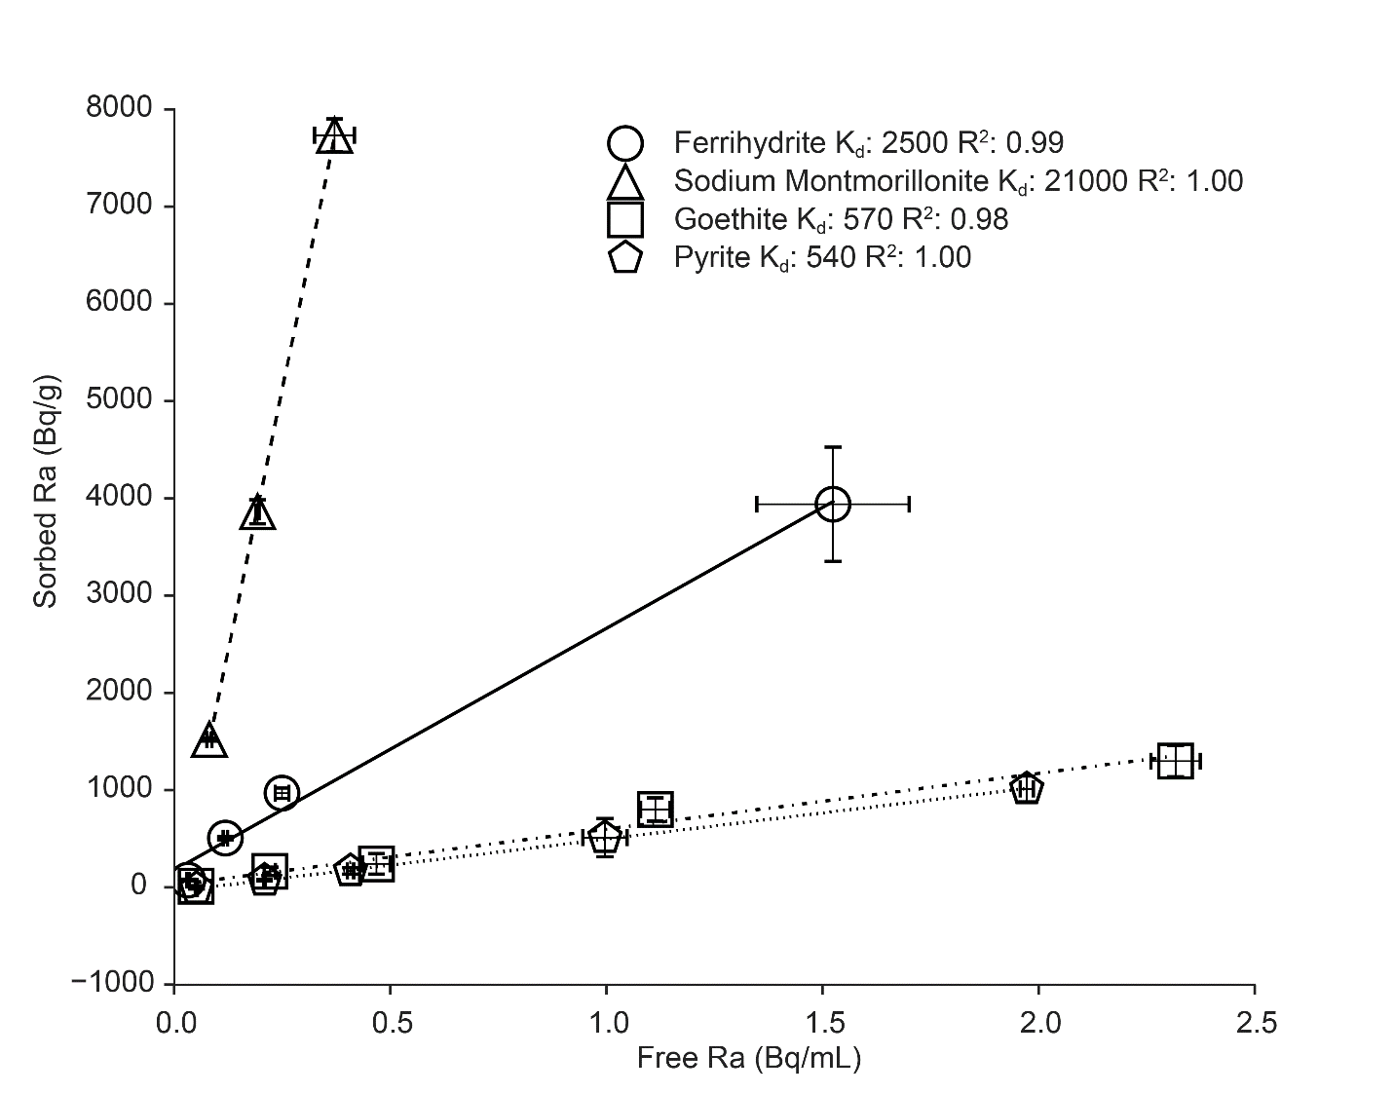

Figure 1. Effect of pH on radium-226 sorption to ferrihydrite. The trends seen here (increasing sorption with increasing pH), are reflected in the other minerals as well.

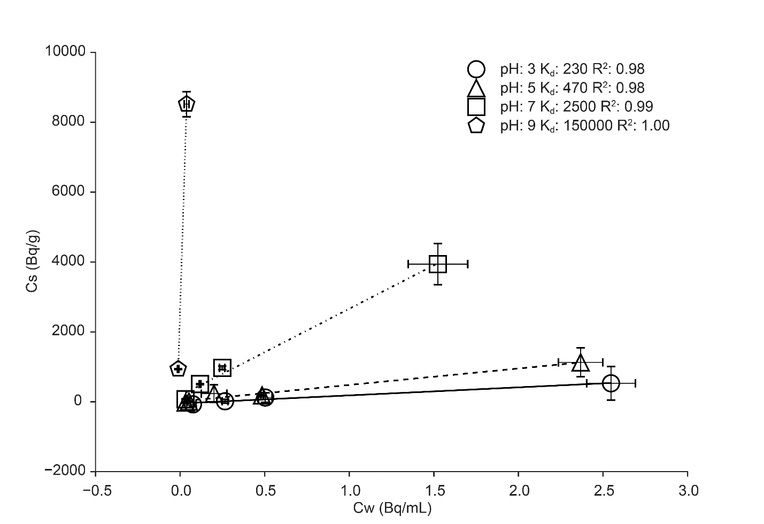

Figure 3. Surface complexation model fits of experimental data. Top: Ferrihydrite, Bottom: Sodium montmorillonite.